1. Find the total revenue (price × quantity) for each item, sorted from highest to lowest.

db.sales.aggregate([{

$group: {

_id: "$item",

totalRevenue: { $sum: { $multiply: ["$price", "$quantity"] } }

}},

{

$sort: { totalRevenue: -1 }}])

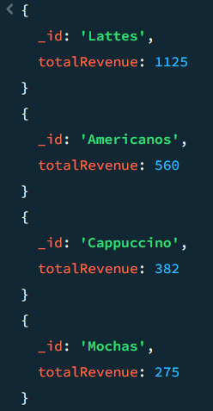

2. Calculate the total quantity sold per month in 2022.

db.sales.aggregate([{

$match: {

date: {

$gte: ISODate("2022-01-01"),

$lt: ISODate("2023-01-01")

} }},

{

$group: {

_id: { $month: "$date" },

totalQuantity: { $sum: "$quantity" }

}},

{

$sort: { _id: 1 }}])

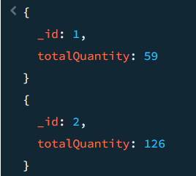

3. Find all items where price is greater than 10 and size is not 'Short'.

db.sales.find({price: { $gt: 10 },size: { $ne: "Short" }})

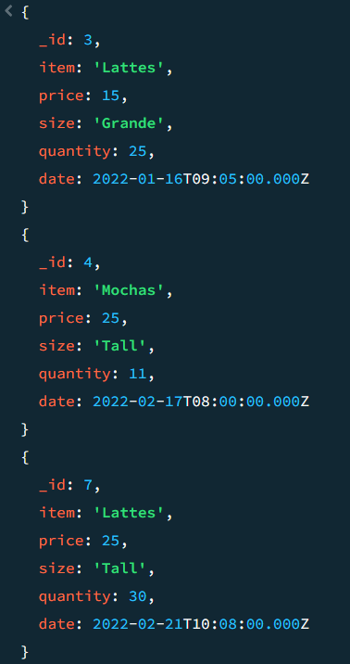

4. Get all Cappuccino sales with quantity between 10 and 20.

db.sales.find({item: "Cappuccino", quantity: { $gte: 10, $lte: 20 }})

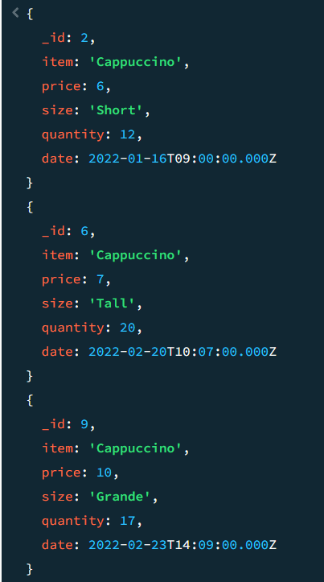

5. Query to find items where the item name starts with "A".

db.sales.find({item: /^A/})

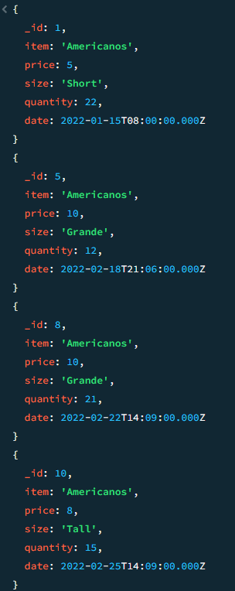

6. Find all records that do not have the field size.

db.sales.find({size: { $exists: false }})



7. Find all sales that are either "Grande" or "Tall" but not "Americanos".

db.sales.find({size: { $in: ["Grande", "Tall"] },item: { $ne: "Americanos" }})

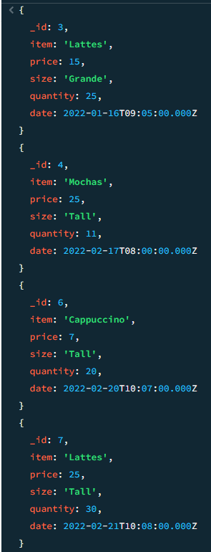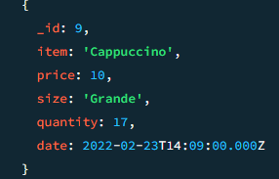

8. List all items sold in February 2022.

db.sales.find({date: {$gte: ISODate("2022-02-01"),$lt: ISODate("2022-03-01")}})

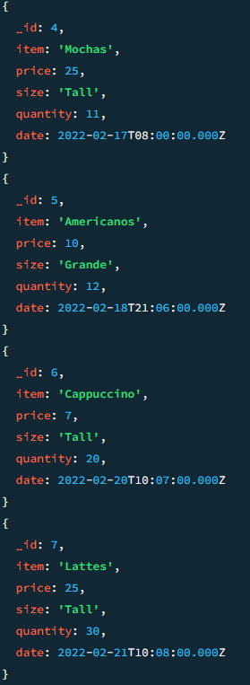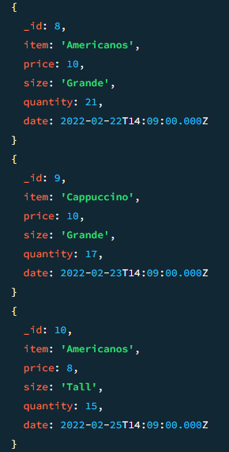

9. Find sales where the quantity is more than twice the price.

db.sales.find({$expr: { $gt: ["$quantity",{ $multiply:[2, "$price"]}]}})

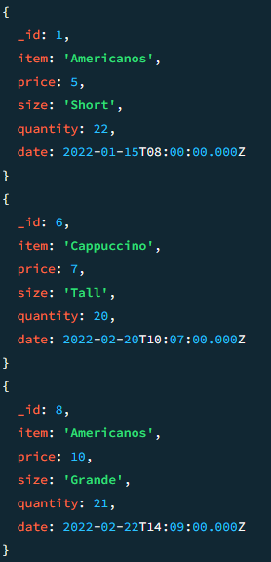

10. Find all sales where the price is greater than the average price of their respective size.

db.sales.aggregate([

{

$group: {

_id: "$size",

avgPrice: { $avg: "$price" }

}}])

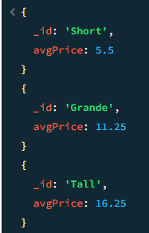

11. Filter sales where the total revenue is even and exceeds 100.

db.sales.find({   
$where: function()   
{ const total = this.price * this.quantity;   
return total > 100 && total % 2 === 0; }

})

11. Find Sales Where the Day of Week Matches Quantity's Last Digit [Filter sales where the day of the week (0=Sunday, 1=Monday, etc.) matches the last digit of quantity]

db.sales.find({

$where: function() {

const day = this.date.getDay();

const digit = this.quantity % 10;

return day === digit;

}})

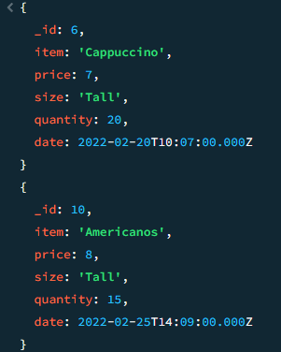

12. Find Sales Where the Month is Prime and Quantity is Odd [Filter sales where the month (1-12) is a prime number (2,3,5,7,11) AND quantity is odd]

db.sales.find({

$expr: {

$and: [

{ $in: [{ $month: "$date" }, [2]] },

{ $eq: [{ $mod: ["$quantity", 2] }, 1] }

]}})

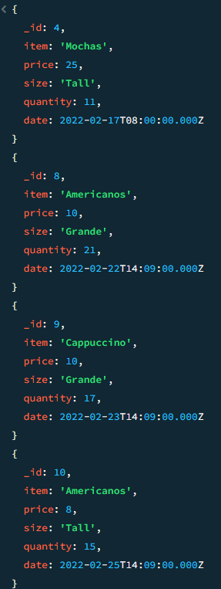

13. Find Sales with "Suspicious Quantities" (Divisible by 5 or 7) [Filter sales where quantity is divisible by 5 or 7]

db.sales.find({$or:[{quantity:{$mod:[5,0]}},{quantity:{$mod: [7,0]}}]})

